Coleorton and New Lount Volunteer Group
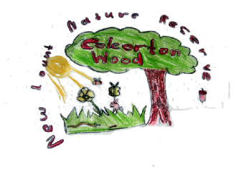

by Tom Raffle aged 10 years

REVIEW OF 2019
The group has now been in existence for nine years, over which period very significant progress has been made. We have again in 2019 managed, with the help of other organisations, to achieve a record number of volunteer hours, exceeding 2,200 for the year.
The group continues to be strongly supported by the LCC Country Park Rangers, whose help and guidance continues to be invaluable. This year saw James move to the Beacon Hill Country Park, resulting in the recruitment of new country park ranger, Buffy, who has already been very supportive of the group.
Coleorton Parish Council also continues to support the group and its activities at Coleorton Wood, where great progress is also being made.

New Lount Nature Reserve.
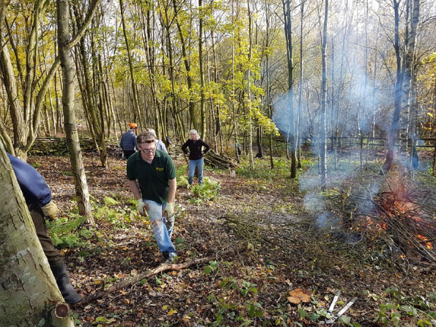
After a three year period, we have now completed the woodland thinning of the planted woodland area that encircles the sides and top of the colliery pit bank. Due to the number of trees that we had to remove from this area, we have had to construct probably too many windrows, and what could not be sensibly made into windrows we have had to burn-off. We have however been able to utilise some of this timber by cutting some of it into logs, which were then sold to the local community in an October Log Sale. We are now planning to go back to the total area thinned and carryout some more selective thinning; looking at the possibility of under-planting other tree species. The result of the thinning completed has made a very significant difference to this area of the reserve, with much more vibrant undergrowth throughout. We have also had to remove a substantial quantity of old rabbit fencing to give access to main areas of this woodland.
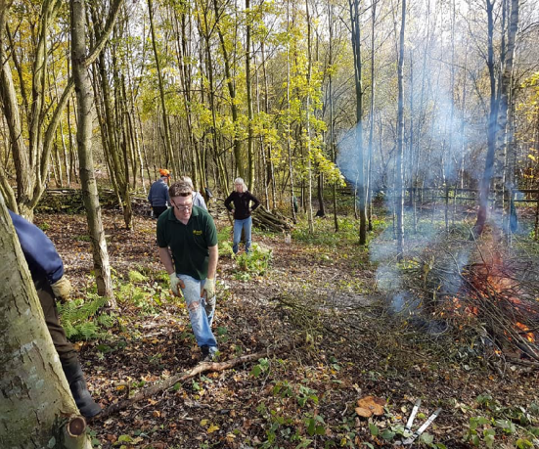

Woodland Thinning at New Lount Reserve

The other main method of habitat management we have employed throughout the year is the strimming and raking-off of grassland and the ride edges. The large complex site has a number of substantial areas that need to be strimmed once a year and without the use of powered tools we would not be able to achieve a fraction of what we do achieve.

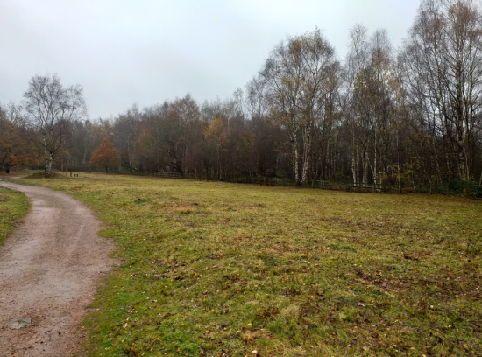

Species Rich Grassland after strimming and raking-off
The large species rich grassland area has shown fantastic progress year on year and we were very fortunate, this year, to get a large growth of both Common Spotted Orchids on one side of the area, and Bee Orchids on the other. Whilst the Bee Orchids are not new to the site, this is the first year since the group started when they have been recorded. We were all very excited to see the wonderful display of these small orchids.
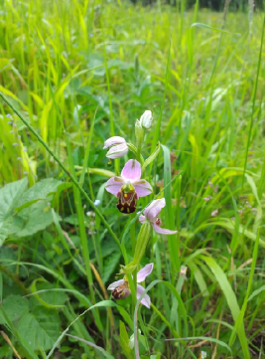

Bee Orchid in Species Rich Grassland

We also have three open glades which the group created some years back, and with the year on year strimming of these we now have three more interesting and biodiverse areas in the reserve.
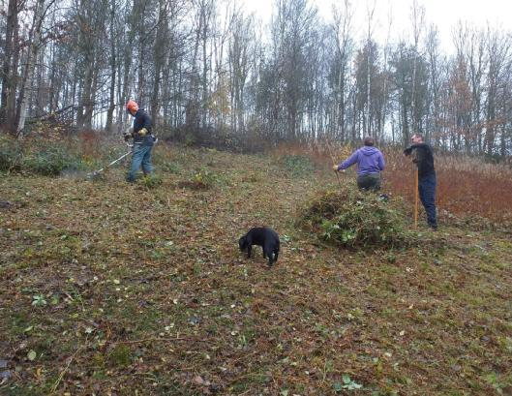

One of the open glades being strimmed and raked-off
There are a number of other areas which we have managed to strim-off, which helps to keep the marauding brambles at bay. However, we also have a large number of areas where we just do not have the resources to strim, and some of these will be reverting to scrub, and then to woodland. We would need to have a significant increase in volunteer hours to keep on top of all these areas.
The grassland areas on the top of the colliery pit bank represent a very large area that would take a lot of volunteer hours to maintain by strimming and raking-off and are now in need of cutting back. The Rangers have arranged for these two areas to be mown by a contractor. Where necessary we have been removing saplings in these areas.
The rides throughout the site also become overgrown and we have spent some of our time strimming these to keep them looking tidy, and clear of brambles. One area we focus on throughout the year is the front entrance of the site and the road leading into the site. This has been strimmed twice throughout the year and we have also managed to tidy up part of the back entrance road into the site.
We have strimmed and kept tidy both of the two picnic areas as well as keeping an eye on the Forest School area in which we have strimmed to remove nettles.
We have also had to take down a number of trees throughout the site that have become unsafe. The largest of these was in the car park picnic area, a Willow, which was cracking down its centre. We also had to cut up a very large tree which had fallen near to the car park and was partially blocking one of the rides. This tree enabled us to cut some large logs which the Forest School have used as seat for the children. There have also been a number of partially fallen trees which we have taken down to make sure they are safe.
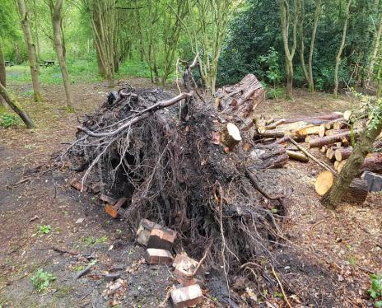

Roots of the very large tree blocking the ride
We have carried out some tidying-up work, strimming and cutting back, on the areas in front of the Colliery Heritage Trail boards. This has included the weigh bridge area, the tub tracks area and the canteen area, where we have treated the tree stumps with “Eco Plugs” to prevent re-growth.
As part of our site maintenance work we have carried out a number of fence repairs, particularly to the fences near the bottom open glade. We have also spent time walking the rides to clear any vegetation which is reducing access, particularly as there has been a significant growth-spurt with this year’s weather.
This year we have also re-painted both the front gates and the metal fences leading into the site as well as some metal rails in the car park. This helps to keep the entrance to the site more inviting. We have helped the rangers to install two new dog-litter bins around the car park areas.
Over the years we have not had the time, or resources, to manage the three main ponds, but this year we did devote a work session to surveying two of the ponds by having a “pond dipping session”. This was very useful and gave us an indication of the general health of the two ponds. It was also something very different from our normal work sessions and was thoroughly enjoyed by all who took part.

Coleorton Wood.
The main habitat management we have carried out this year has been the coppicing and cutting back of the woodland edges, which was on an 8 year cycle according to the old management plan. We have therefore had to complete the work for years 6, 7 and 8 this year, and that programme is now complete. The new management plan has reduced this to a five year cycle, but we are only clearing one side of the woodland rides at a time.
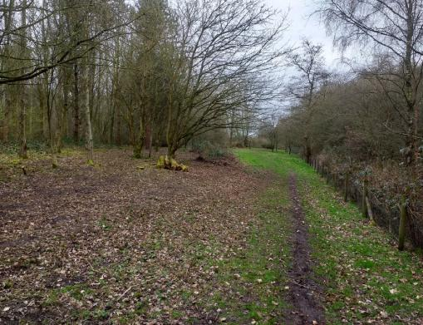

Woodland edge that has been coppiced and cleared.
We have started this cycle from autumn 2019 and will complete the first year by the end of winter 2020. As the growth being removed is five years old we are able to do most of the cutting with the clearing saw. Most of the cuttings are being burnt-off although we make a few windrows as we progress with the work. We are also looking at the Hazel stems to see if the best can be taken out and used, or sold.
In some areas as we have been coppicing the woodland edges we have also removed some trees to compliment the woodland thinning that the contractors carried out.
We also have one area where the Dogwood has come back at the expense of other planted species. We have strimmed and cut back this total area and will see what we can do to reduce the growth of the Dogwood. The area will be monitored to check the Dogwood growth.
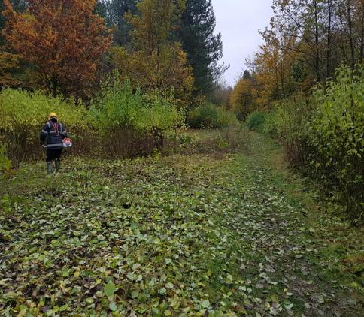

Stimming back Dogwood at Coleorton Wood
We have also been strimming and raking off areas where we have open areas of grass as well as the ride edges. Throughout the summer period we allow these areas to grow and only strim them in the autumn/winter period. We do however have just a few open areas which we strim throughout the summer to control the nettles and brambles. We are creating more small open areas around the site to help improve the biodiversity of the wood.
This year we have created a small open glade in part of the woodland near the pond and we have created access to this area. We will continue to monitor the area and maintain it as a larger open grass area.
Most of the remaining work on the site has been site maintenance in one form or another. We have had to carryout frequent surveys of the site to cut back overhanging vegetation on the rides due to the significant growth throughout the summer season. We have also taken down a small number of trees which for one reason, or another, were unsafe. The occurrence of windblown trees has significantly reduced in the wood.
We have maintained the car park throughout the year by strimming the edges and cutting back overhanging vegetation. We have cleared the area around the “Royal Oak in the car park to give it more light and space to develop. We have retreated the noticeboard in the carpark, but we could really do with a new board which is suitable for both notices and general information about the wood. We will set this as a project for 2020. We have unfortunately had a recent incident of “fly-tipping” in the carpark, which as well as mainly consisting of garden waste also included a refrigerator. We have moved the garden waste into the woodland to rot down and the refrigerator will be removed by the council. The group has also cut the hedge at the bottom of Pitt Lane.
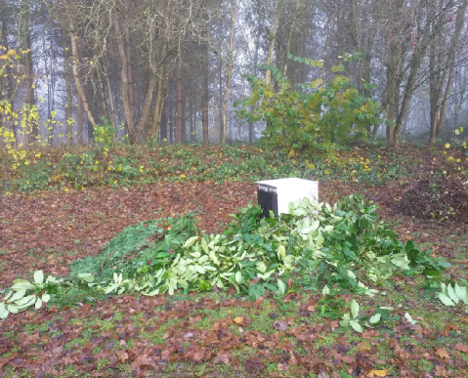

One of the piles of Fly-tipped waste in the car park.
Due to the very long and heavy periods of rain we have kept a close monitor on the flow of water into and out of the pond. Most of the excess water has been diverted around the pond to avoid the pond overflowing. We have been able to remove some of the encroaching reeds to keep more open space in the pond. The area in front of the pond has been strimmed and
the brambles cut back. The very wet weather has resulted in a small number of work sessions being cancelled.
We have also taken down a small number of specifically large Larch trees and then cut large supports with the milling attachment. These large supports will be used to construct a bird-hide at New Lount Reserve. The milling attachment has also been used to cut more planks, which will also be used on the bird-hide.
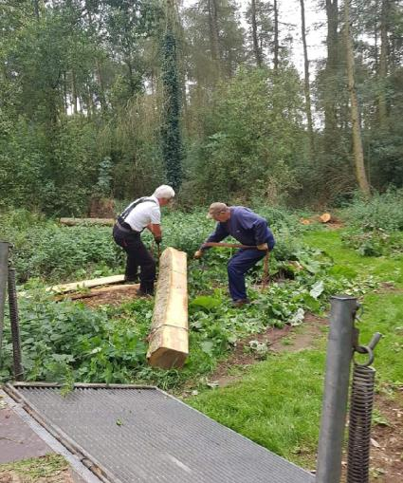

Moving the large supports from Coleorton Wood.

Workshop.
The workshop started the year manufacturing picnic tables for LCC, which were required for a new cafe at Country Parks Beacon Hill site. These were completed in time for the opening and members of the group were invited along for the official opening.
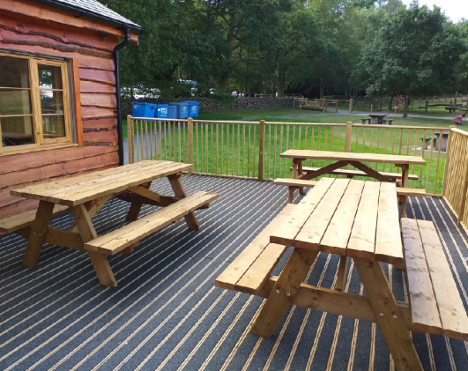

Picnic tables at Beacon Hill Country Park cafe.

The workshop group was then asked by LCC to makes railings to be installed at Bosworth Country Park. These were manufactured in oak and along with the size required proved to be more difficult without the most appropriate tools. They were however completed at the time specified and the workshop group assisted in their installation.

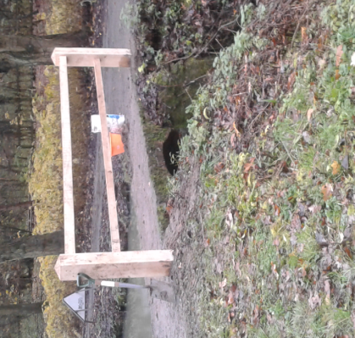

One set of railings installed at Bosworth Country Park.
We also had our annual Christmas Reindeer Evening and there was some predatory work required which was carried out by the Workshop group.
The group has now been asked to manufacture more picnic table for LCC and they may also manufacture some memorial benches.

Social and Fundraising.
The major fundraising event for this year was again the plant sales held in May. These were very well attended and we were well supported by local businesses who contributed plants. Members of the volunteer group also grew plants to sell at the events and some plants were also sold direct from outside one volunteer’s house The events raised over £1,000, but is not likely to take place in 2020 as a result of changes to the availability of plants.
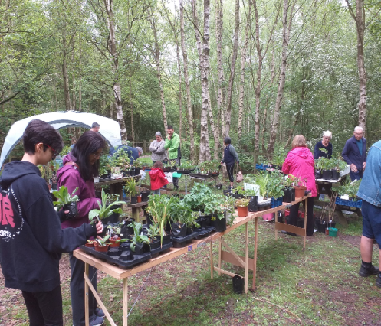

Plant Sale at New Lount

Plant Sale at New Lount Reserve

In October we had our first Log Sale, which was held at New Lount Reserve and was very successful raising over £450 after we had sold out of cut logs. The group had worked hard to get sufficient logs cut by the date and some of the more active members were actually splitting logs on the day. The advantage of such event is that it makes some use of the wood cut down for habitat management as well as contributing to the local community. We will look to repeat this type of log sale next year.

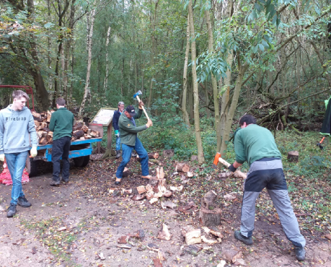

Volunteers splitting logs at the Log Sale
Christmas saw the annual “Reindeer Evening” which is a social event where volunteers and guests can make reindeer and snowmen decorations at the Snibston workshop. This is always very well attended and very enjoyable as it includes both snacks and drinks brought along by all.
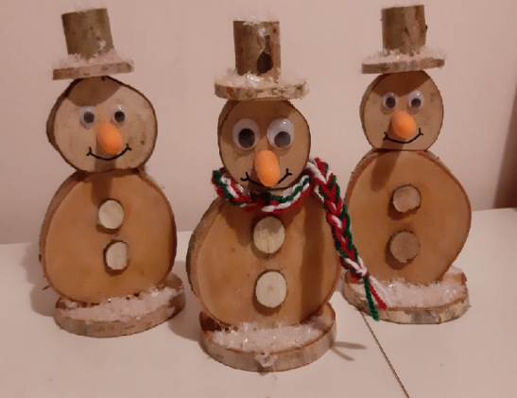

Some snowmen made at the “Reindeer Evening”

